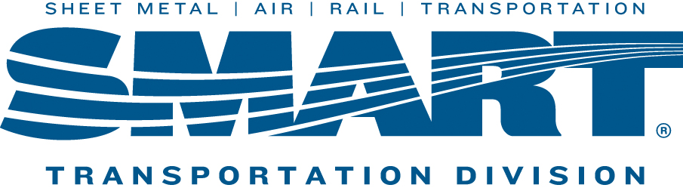

NEXT LOCAL 1440 UNION MEETING WILL BE HELD ON
November 8th, 2022
Trackside Restaurant
61 New Dorp Plaza
4:30PM
(Directly Across from New Dorp Train Station)
Agenda Includes
- Tally of Ballots and Election Results
- General Chairman Report
- The Local 1440 moving forward in 2023

**In order for your voice to be heard you must attend the meeting**

