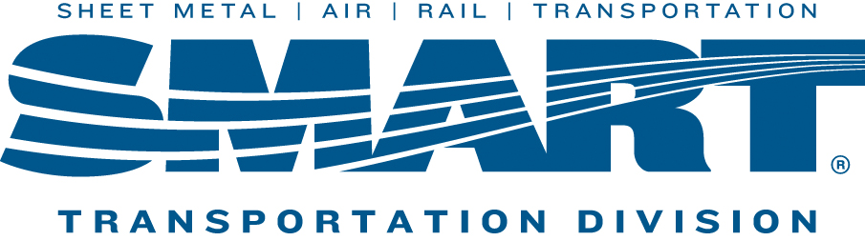

NEXT LOCAL 1440 UNION MEETING WILL BE HELD ON
January 11th, 2022 @4:30 PM
VIA Zoom
Link to the Invite will be sent by Email
**In accordance with the rules set forth by SMART holding virtual meetings. Some topics may not be discussed through Zoom.**

