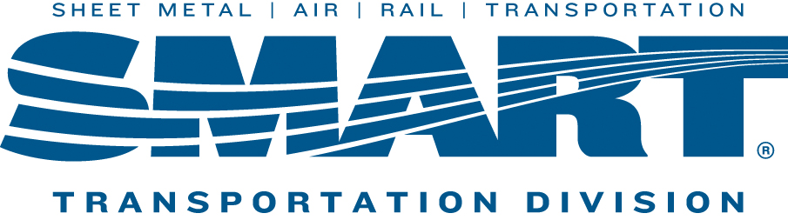

NEXT LOCAL 1440 UNION MEETING WILL BE HELD ON
Wednesday February 15th, 2023 4:30
Trackside Restaurant
61 New Dorp Plaza
(Directly Across from New DorpTrain Station)
AGENDA
- Update on the Retro Pay
- Safety Concerns
- Membership Involvement
- Questions, Comments, Concerns
Starting this month we will have a 50/50 Drawing every meeting.

